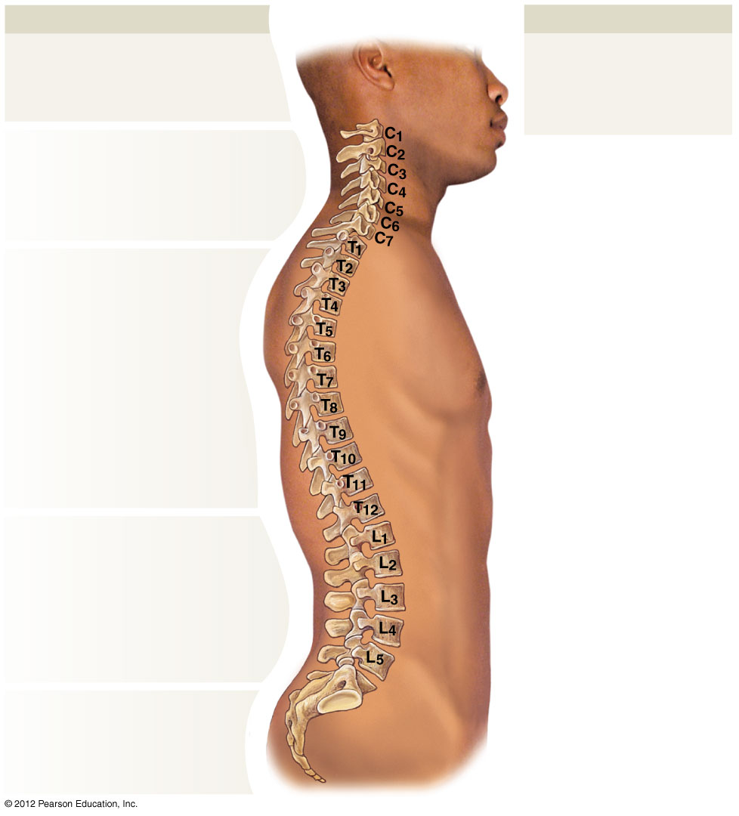

**Vertebral Regions**

**Regions are defined**

**by anatomical**

**characteristics of**

**individual vertebrae.**

**Cervical**

**(7 vertebrae)**

**Thoracic**

**(12 vertebrae)**

**Lumbar**

**(5 vertebrae)**

**Sacral**

**Coccygeal**

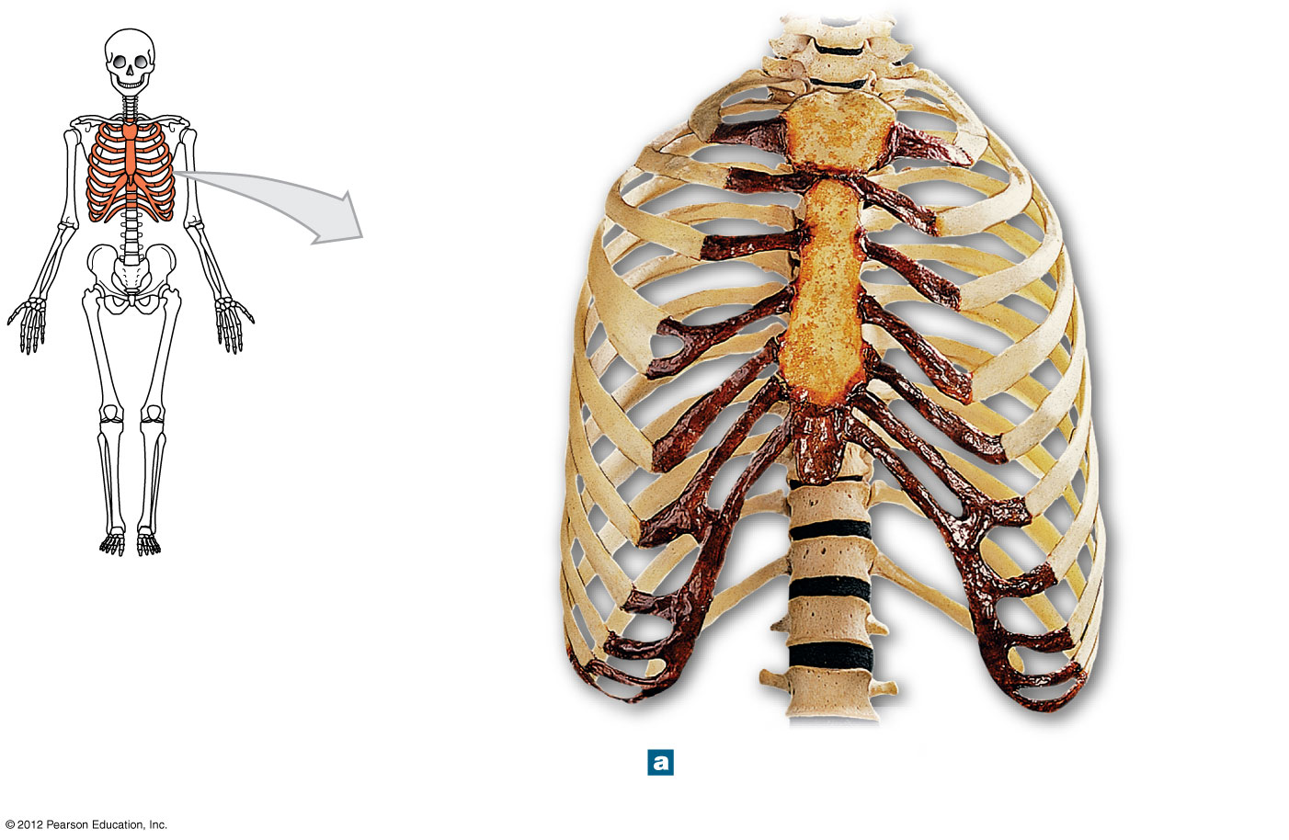

**Jugular notch**

**Clavicular articulation**

**Manubrium**

**Sternum**

**Body**

**Xiphoid**

**process**

**Costal**

**cartilages**

**True ribs**

**(ribs 1–7)**

**False ribs**

**(ribs 8–12)**

**Floating ribs**

**(ribs 11–12)**

**Vertebrochondral**

**ribs**

**(ribs 8–10)**