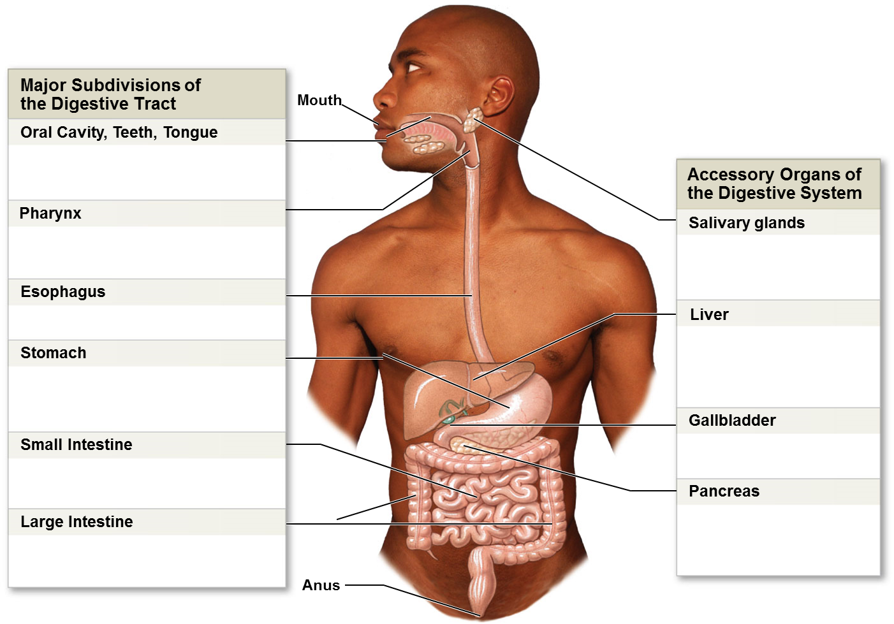

Matching (fill in the box with the correct letter)

- Enzymatic digestion and absorption of
water, organic substrates, vitamins, and ions
- Chemical breakdown of materials by acid
and enzymes; mechanical processing
through muscular contractions
- Exocrine cells secrete buffers
and digestive enzymes;
endocrine cells secrete
hormones
- Enzymatic digestion and absorption of
water, organic substrates, vitamins, and ions
- Mechanical processing, moistening,
mixing with salivary secretions
- Muscular propulsion of materials into the
esophagus
- Transport of materials to the stomach
- Secretion of bile (important
for lipid digestion), storage of
nutrients, many other vital
functions
- Secretion of lubricating fluid
containing enzymes that
break down carbohydrates
- Storage and concentration of
bile
