Anatomy Quiz: Neuron and Neural Classification KEY
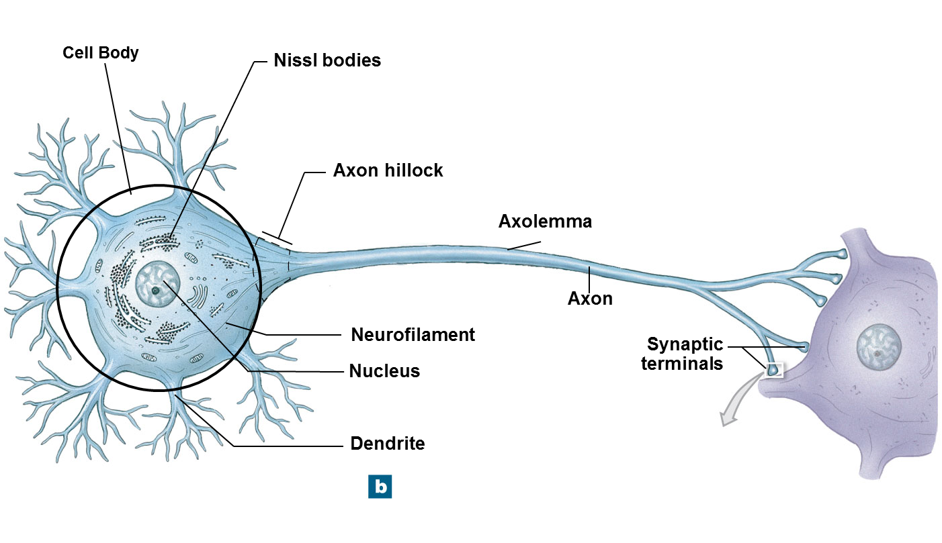
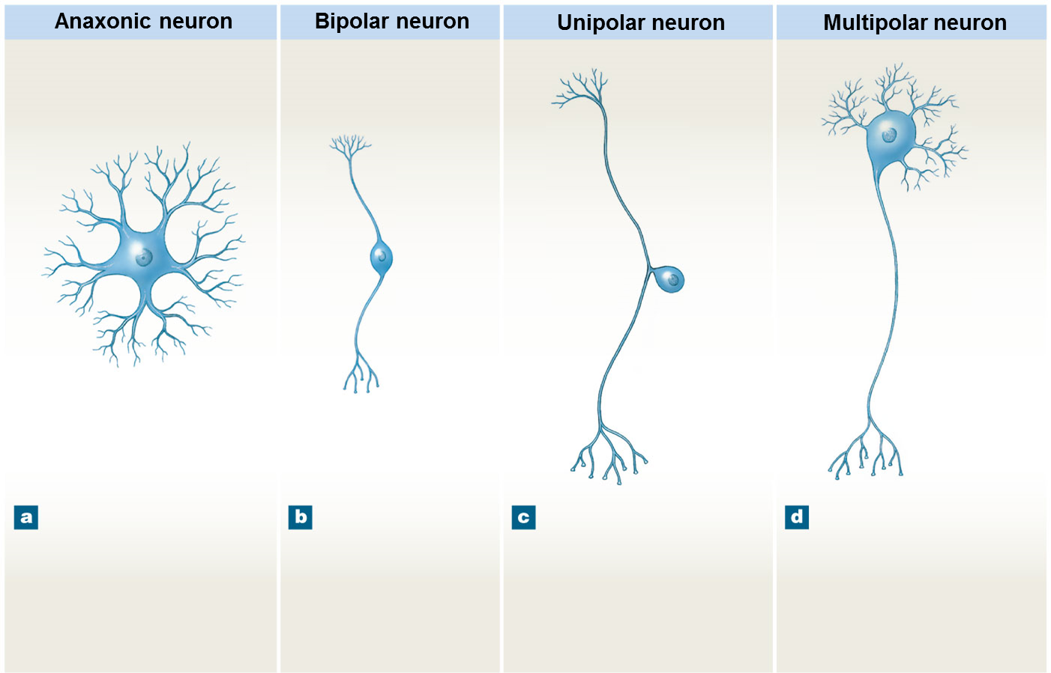
Make a flow chart showing the divisions of the nervous system. (8 points)
