Anatomy Quiz: Neuron and Neural Classification Name:__________________________________
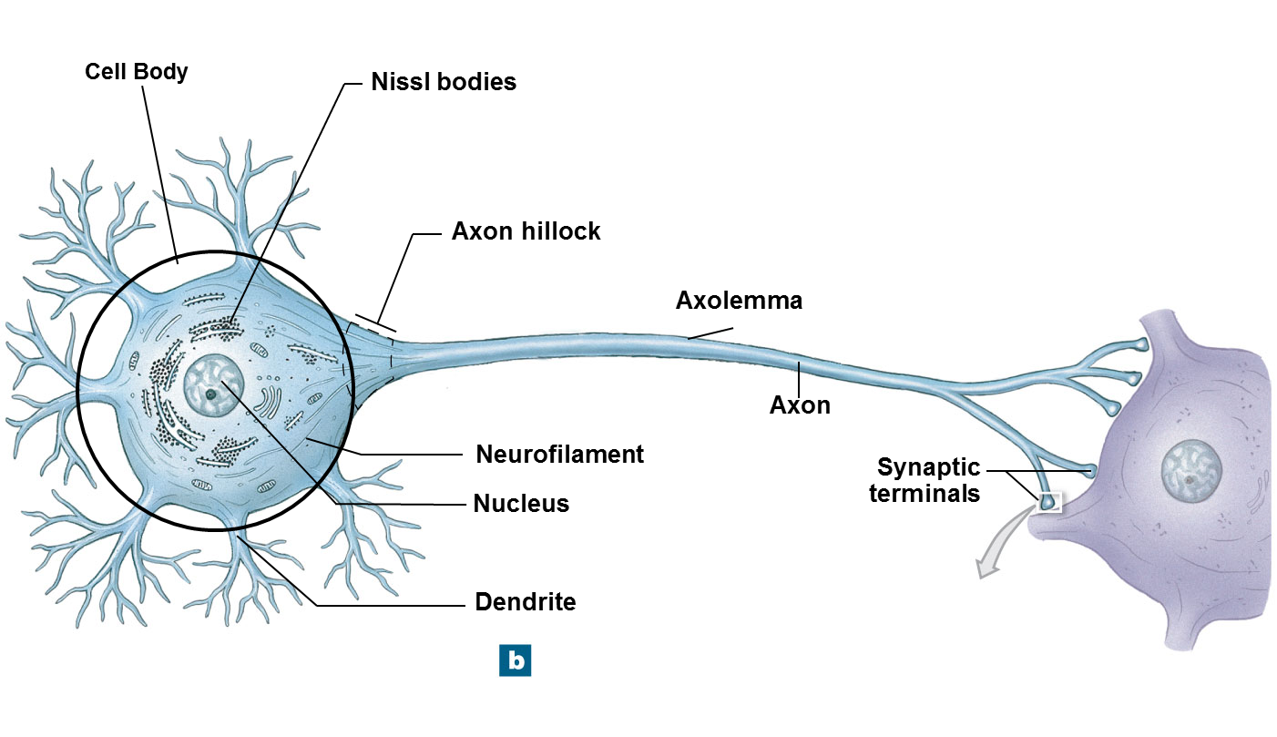

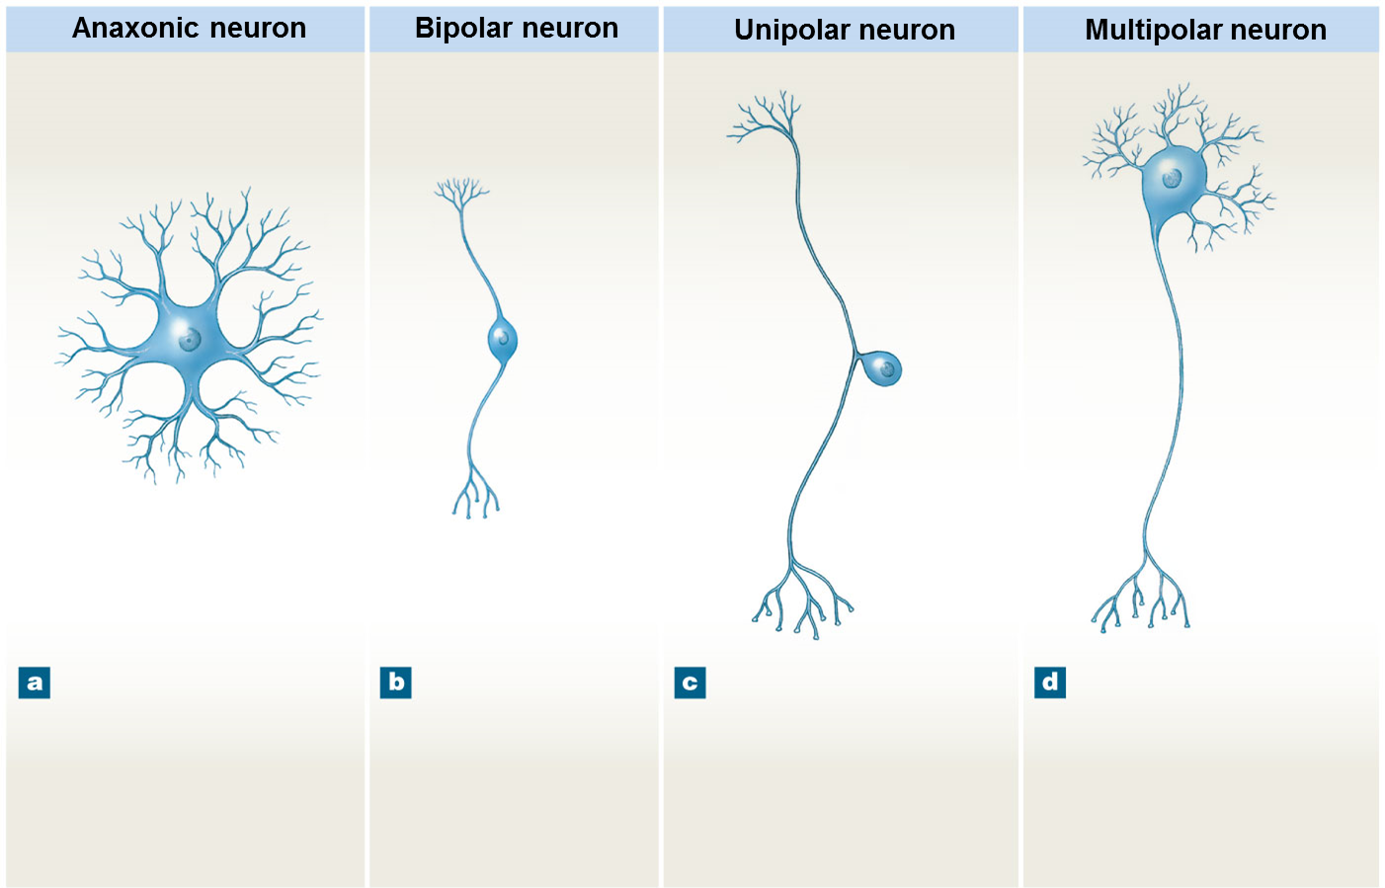

Make a flow chart showing the divisions of the nervous system. (8 points)
